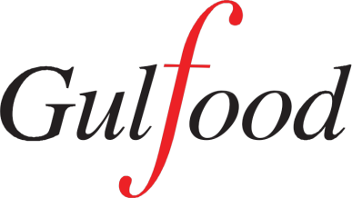  Gulfood Expo | Belgian Pavilion at the GulFood Expo  18 – 22 February 2018 Trade Centre Arena Sheikh Saeed Hall - Stand S2-B4 / S2-C27  Dubai World Trade Centre

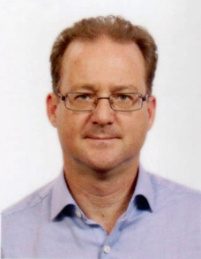 | Mr Christophe Van Overstraeten, Trade Commissioner, Embassy of Belgium in India, shall be present at the Belgian Pavilion at the Gulf Food Expo 2018 (Trade Centre Arena-Sheikh Saeed Hall-Stand S2-B4 / S2-C27) for the duration of the Expo. For appointments with any of the exhibiting Belgian companies, he can be contacted at :  Email: newdelhi@awex-wallonia.com

Belgian Companies at Gulf Food 2018

ALIMAD FOOD
Stand N°S2-C23
www.alimad.be
Specializing in liquid and semi-liquid food products, Alimad was created in 1985 in Brussels. In 2006, a subsidiary named Alimad Food opened a new production site, in Ghislenghien. Their oriental Fine Pastry products are by far the best in the market, in terms of quality, aroma, flavour and price.
Product range : Orange flower water, rose water, honey flavoured glucose syrup, lemon specialty. 4 food colourings (Blue, Red, Green and Yellow) 12 flavours (almond, banana, lemon, orange blossom, pineapple, strawberry, pistachio, rose, orange, coffee, chocolate and vanilla)

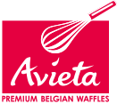 | AVIETA  Stand N°S2-C27
www.avieta.com
Avieta has been baking waffles for more than 80 years from the heart of the Belgian countryside. The family owned company has worked hard to maintain the artisan’s baker’s ways of preparing the unique waffles dough using the best local ingredients. Avieta waffles are produced in its bakeries in Belgium and distributed by major food groups (branded, distributor’s label, co-packing), both at Retail and in Food Service.

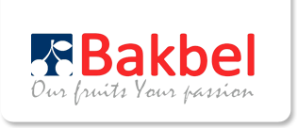 | BAKBEL EUROPE  Stand N°S2-C3
www.bakbel.be
Established in 2007, Bakbel is the specialist in producing high quality and innovative ingredients for the pastry and bakery industries. To achieve this goal, Bakbel has a state of the art facility with high standards of production and food safety. In this purpose-build facility the company produces high quality, fruit based ingredients, created especially for the premium fine pastry industry and food service market.

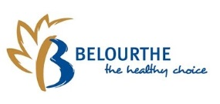 | BELOURTHE  Stand N°S2-B8
www.belourthe.be
Belourthe is a Belgian cereals manufacturer. Its plant is among Europe’s largest cereals processing sites, with a production capacity up to 20.000 tons/year. Belourthe is the European expert of baby nutrition and the ideal partner for all babyfood projects. Belourthe offers a large range of products from milk to cereals, baby cereals (4 months to 3 years) 3 stages of milk (infant, and 2 stages of follow up milks) and much more.

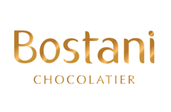 | BOSTANI CHOCOLATE Stand N°S2-B18
www.bostani.be
Bostani Chocolate was established in Belgium in 2014. Its a company specialised in manufacturing premium Belgian and customized chocolate for every occasion.

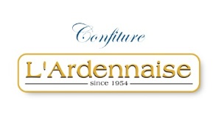 | CONFITURE L’ARDENNAISE  Stand N°S2-C13
www.confiturelardennaise.com
For more than 65 years, Confiture l’Ardennaise, is manufacturing one of the finest organic and traditional jams in the world. Thanks to a partnership developed with the University of Copenhagen in Denmark, the cooking process has been patented in 2016. But, what are the criteria of quality? It’s simple; the fruit that has been carefully selected at low temperature is cooked (no more than 65°C) and the evaporated aromas are regained and injected again in the final product. That gives fruit products a rich colour and intense taste.

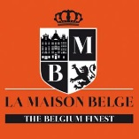 | DELKA  Stand N°S2-B6
www.lamaisonbelge.be
Delka is a sauces manufacturer since 1954. They produce several sorts of cold and hot sauces, mayonnaise and dressings in jar, top down squeeze and old fashioned jars, jam and chutney in jars with its brand and private label. Its customers are: retailers, wholesaler for Food Service and Fine Food distributors.

EUROFIT
Stand N°S2-B20
www.eurofit.be
Eurofit specialises in the manufacture and distribution of dairy products and has carved out a position for itself as a preferred partner of the food industry and supermarkets. The Eurofit product range includes:
Supermarket sector: long-life products (UHT milk, cream, concentrated milk, coffee cream, soya beverages, infant food, etc.) fresh products (yoghurts, soya desserts, dairy beverages, etc.) and frozen products (ice creams, filled pancakes)
“Industry” sector: unpasteurised milk, concentrated milk, cream, buttermilk, goat’s milk, sheep’s milk, milk powders, lactoserum (demineralised), caseins - caseinates, etc.
Tailored-made recipes: their subsidiary WDI, located in Brittany, offers a wide range of customized powders for the food-industry.

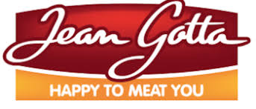 | GHL GROUP  Stand N°S2-C21
www.jeangotta.be
Founded in 1975 and based in Aubel, GHL is specialized in the deboning and the processing of beef meat from the carcass to the case ready products.
Product range : Belgian beef meat (Belgian Blue Breed…) in quarters, or boneless and vacuum packed (fresh or frozen), case ready meat. Large range of products as for instance: beef meat enriched with Omega 3, diet, organic, Halal…
Main references : Leading supermarket chains like Carrefour, Delhaize, Colruyt, Intermarché, Spar…

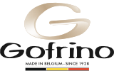 | GOFRINO BY GAUFRES GEURTS  Stand N°S2-C7
www.gofrino.eu
Gofrino produces traditional sugar waffles and waffle dough for its customers worldwide. Its traditional products adhere to the traditional methods and recipes of yesteryears, using quality ingredients. For almost 35 years, its production workshop in Belgium has been the leading producer of healthy and artisanal waffles. The Gofrino products are available in various sizes and weights, frozen dough pieces of Liège waffles and cooked frozen waffles, under Gofrino brand or a private label brand.

HUGO WAFFLES
Stand N°S2-B14

www.sowaffelous.be
The company is specialized in the production of premium waffles. It uses only the best ingredients to ensure the high quality. Its new brand “So Waffelous” has been developed for export markets. They also offer waffles with no added sugar.

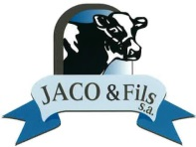 | JACO ET FILS  Stand N°S2-C19
www.jacoetfils.com
Jaco & Fils has been a family run business for three generations specializing in the production and distribution of quality meat. The company sells everything related to cattle in general and offers a wide range of products: Steak, ribeye, tenderloin, etc. (every cut of the cow in vacuums), quarters of cow in vacuums with or without bones. It also offers all types of offal such as liver, heart, etc...

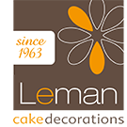 | LEMAN CAKE DECORATIONS  Stand N°S2-B24
www.leman.be
Since 1963 Leman Cake Decorations is a leading brand in the fashion world of cake decorations. With a chocolate production in Belgium and a sugar production in Thailand Leman is offering the widest collection of cake decorations. Transfer sheets, ready-to-use chocolates, sugar and marzipan decorations, direct import of plastic decoration, personalization,… Leman is offering the finishing touch for your creations.

LEVEAU, ETS
Stand N°S2-C5
www.brasserieada.be
Like many Belgian abbeys, the Cistercians of Aulne Abbey had been brewing their own beer since the middle ages. The abbey had to provide for about 1000 monks and friars. Strong beers like the Blonde, Brune and Triple were served on special occasions. Light beers were for daily consumption. In 1849 the brewery was closed. Some 100 years later lay persons were allowed to brew abbey beer for the first time. Brasserie de l’Abbey de l’Aulne revived the brewing business in 1950. Today the abbey produces its specialty Belgian beer following the traditional brewing arts of its founders, the Cistercian Monks of Aulne Abbey.

MYDIBEL
Stand N°S2-B4
www.mydibel.com
The Mydibel Group is a family business specializing since 1988 in the development production and commercialization of potato products : including chilled (fries), frozen (fries, hash browns and purée specialities) and dehydrated (flakes and granules) products. Mydibel invests both in their own branding and in private label supplying companies from a variety of customer segments : food segment, retail and industry.

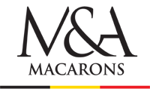 | PMSWEET  Stand N°S2-B12
www.pmsweet.be
Luxury artisan patisseries intended for the catering sector, distributors and export. A Belgian company specialising in the production of artisan-crafted macarons, PMSWEET shares and exports its know-how to professional gourmets.
Product range : Sweet & Savory Macarons, Eclairs, Ispahan, Vegan products, Gluten free products, …
Certification : IFS, HALAL, KOSHER

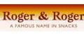 | ROGER & ROGER  Stand N°S2-B28
www.rogerandroger.com
This family business produces and distributes crisps to over sixty-five countries since 1999. It works with 250 enthusiastic, flexible and ambitious employees. It manages the entire production of its broad range, from harvesting raw materials to packaging and distribution. It works with various shapes of potato and tortilla chips. Its products are available under private label or one of its brands Croky/Crackito/Roger’s/ Crokido’s. Western Europe is its home market; the number of export markets is growing fast.

SIROPERIE MEURENS
Stand N°S2-C15
www.sirop-de-liege.com
Since 1902, Siroperie Meurens has been processing fruits in the most natural and clean way, preserving them without using chemicals, without compromising on efficiency. The company produces fruit spreads, purees, juices and juice concentrates for retails, food service and industries.

Index
Bakery products | PM Sweet
Beer | Ets. Leveau
Cake decorations | Leman Cake Decorations
Chocolates | Bostani Chocolatiers
Food products, semi liquid | Alimad Foods
Fruit, juices, spreads, etc. | Siroperie Meurens
Infants milks & cereals | Belourthe
Ingredients for bakery | Bakbel
Jams | Confitures l’Ardennaise
Jams, sauces, chutneys | Delka
Meat & meat products | GHL Group
 | Jaco & Fils
Milk, creams, yoghurts | Eurofit
Potato fries & other products | Mydibel
 | Roger & Roger
Waffles | Avieta
 | Gofrino
 | Hugo Waffles

